Shooting Review: The CZ P-07
by Andy Rutledge | Jul 26, 2016 | Blog | 13 comments
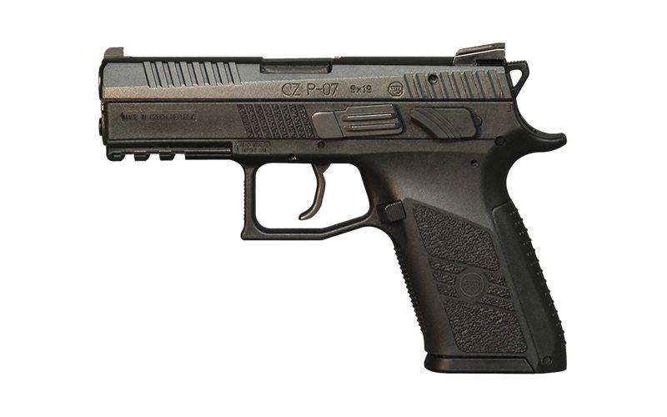

When I got this review assignment I was skeptical. I don’t shoot hammer-fired pistols very often. DA/SA pistols tend to have what I deem to be unnecessarily pesky and distracting features: an inconsistent trigger and operating controls additional to a trigger and slide lock. On that point, some say I’m overly picky. It’s a fair criticism, but a pistol is a very personal tool and I’m a minimalist and want strict practicality from my tools.
By Andy Rutledge
* * *
Other pesky features common to hammer-fired pistols include the clumsiness of an overly high bore axis, obtuse muzzle flip, poor grip texture, and one-size-fits-all grips. The CZ P-07 I recently shot has none of these problems. In fact, after spending some quality time shooting it, I’m rather a fan of this interesting pistol.
The CZ P-07 is the updated version of the CZ 75 P-07 Duty. The changes from the old version amount mostly to some significant tweaks that took a fair pistol toward the realm of excellence. Here are my impressions from having put a few hundred rounds through it. But first, have a look at the specs…

CZ P-07 9mm Specs:
- Chambering: 9x19mm
- Length: 7.2”
- Height: 5.3”
- Width: 1.46”
- Barrel: 3.75” Cold Hammer Forged
- Sights: 3-dot
- Trigger: DA/SA – 7 lbs. / 3.5 lbs.
- Weight: 27.7 oz.
- Finish: Black Nitride
- Safety: Interchangeable Ambidextrous, Decocker/Manual Safety, Safety Stop on Hammer, Firing Pin Block Safety
- Capacity: 15+1
- MSRP: $510 – $524
Features can vary. On its website, CZ offers the following caveats:
Some CZ-USA dealers order special versions that vary from the standard configuration. This might be a difference in sights, safety mechanisms, finish or accessory package. From time to time you may find a P-07 with an extended barrel, tactical light, tritium sights or safety levers only. There are a number of special versions we ship throughout the year. May ship with or without a lanyard loop.

Shooting the CZ P-07
Given the polymer frame, beavertail, and hammer, I was prepared to wrestle with muzzle flip while I shot the P-07. However, when I racked the slide to send the first round home, I noticed that there was very little slide to grab onto. Since the gun was hot, I went ahead and put the five rounds on paper, noticing that there was less muzzle flip than I expected. There was far less muzzle flip, for instance, than I noticed on the HK VP9, which is a striker-fired gun. A good start.
The diminished muzzle flip with this light, polymer frame would seem to come from the fact that the barrel rides lower on the frame because 1) in typical CZ fashion, the slide rides inside channels in the frame and 2) the slide is quite shallow.

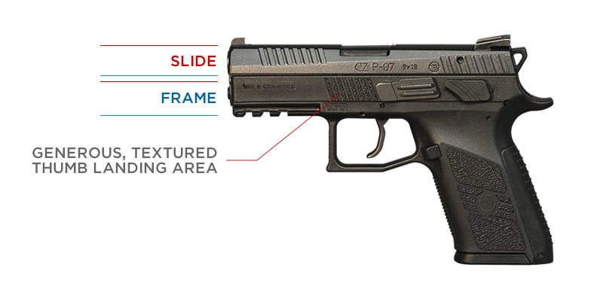

The slide is so shallow, in fact, that it feels a bit odd when you grab the slide to rack it or lock it open. There’s noticeably less steel on which to get a grip. One nice mitigation of this factor is that the slide serrations, front and rear, are quite aggressive. I think this diminished slide real estate would take a bit of getting used to, but it’s all nicely done.
As for the trigger, what a great trigger! The double-action trigger is moderately heavy and not terribly smooth, but also not bad. The single-action trigger is a joy. At around 3 to 3.5 pounds, the single-action trigger is smooth and clean. It’s far better than those on any striker fired pistol I’ve shot and I loved how that translated into easier accuracy for my shooting strings.
I found the magazine release control to be easily located and engaged without modifying grip with my medium-sized hands. When depressed, the magazine is forcibly ejected from the frame. Well done.
Comfort, Controllability, & Capacity
The CZ P-07 is roughly the same size and has the same capacity as a Glock 19, at 15+1. In fact, though the P-07 is hammer fired, these two pistols are in many ways comparable to one another.
I spent some time shooting the P-07 and the G19 one after another. I find the G19 easier to control, as its low bore axis means zero muzzle flip. The P-07 had slightly more muzzle flip, but a far nicer trigger. The P-07’s generous and well-textured support-thumb landing area forward on the frame was a boon to controlling the recoil. I also liked the way the grip fit my strong hand. I was using the medium backstrap and it made for a more comfortable match to my hand than I get with my Glock 19.
The only thing I did not enjoy while shooting the P-07 was how the decocker rubbed the first joint of my support hand thumb. My hands ride high on the frame and the corner of the decocker rests right at my support thumb knuckle. Recoil management translated into repeated abrasion that became quite uncomfortable after 50 rounds or so. Surely this will not be a problem for everyone, as hand size and grip alignment will vary.
Components and Features
As I mentioned earlier, there is very little slide above the frame. CZ’s habit of designing the slide channels into the frame rather than inside the slide means that the slide rides in the frame rather than atop it. Unlike a Sphinx pistol, however, the entire frame is not a slide channel surface and there are dedicated, short slide rails recessed into the polymer frame, as found on most pistols.
The sights are 3-dot. The front sight recesses into the frame and the rear sight is dovetailed. I’m not a fan of the sloping rear sight, but there is a small shelf in front that can allow for the possibility one-handed slide racking. Ideally, this should be a much larger flat surface, though. Even though this is a compact pistol, it comes with an ample picatinny rail for mounting a light or laser.
Being hammer fired, the P-07 comes with a decocker, with levers on both sides of the frame. One interesting customization is that the decocker can be swapped out for a safety lever, and vice versa. So the P-07 allows you to setup your pistol in a way that best suits your preference on that score: either decocked or cocked and locked. A nice feature!
Additionally, the pistol comes with three backstraps so that you can choose the one that best fits your hand. I note that the P-07 grip contour is more ergonomic and comfortable than is found on a Glock pistol (While I’m a big fan, grip ergonomics are not a Glock strong suit). CZ has done a good job here.
Speaking of the grip, the CZ P-07 is one of the few pistols that actually has a serviceable grip texture. The front and back of the grip are aggressively textured and the sides—as well as the forward support thumb area—have and almost sandpaper quality to the texture. This might be the first polymer pistol frame that need not be stippled in order to be safely carried as an EDC gun. Kudos to CZ.

Conclusions
Pros
The CZ P-07’s low-ish bore axis makes it superior to other polymer-framed, hammer-fired pistols and even some striker fired pistols with regard to muzzle flip and target re-acquisition. The customizable grip fit and swappable decocker and safety allow for a more tailored setup.
Both the slide serrations and the grip texturing are well done and allow for excellent purchase on the gun. The trigger is above average overall and the single-action trigger is exceptional. Magazine capacity and shooting controllability are both very nice for a medium-sized pistol. And at around $510 retail, the price is quite reasonable.
Cons
Some will disagree, but I regard hammer-fired action as a genuine flaw on a pistol. Due to this action, there are pesky and distracting gadgets on the frame that the operator must fool with. Not optimal. The sights should be replaced if it is to be an everyday-carry gun and the decocker may cause discomfort and/or abrasion to the shooter’s support hand.
So for rating the CZ P-07…
Ergonomics (****)
The grip is well contoured and comes with varied-size, replaceable backstraps. Winning.
Shootability (****)
Despite the light, polymer frame and the hammer action, the P-07 has minimal muzzle flip. The excellent grip texture and support-thumb landing area texture allow for good control of the frame while shooting.
Accuracy (****)
I found it quite easy to make accurate hits with this pistol. The excellent trigger allows for precise control and easy follow-up shots.
Customization (****)
There are aftermarket sights and plenty of holster options available for the CZ P-07. The replaceable backstraps and decocker-or-safety option allow for good personalization out of the box.

In Summary
The CZ P-07 is a heckuva pistol. While I’m no fan of hammer-fired guns, I found this one pretty agreeable. Were I to own one, I’d have to figure out how to prevent the decocker from rubbing my thumb knuckle raw, but surely for most folks this won’t be an issue.
If you like hammer-fired pistols and want to try and polymer-framed version, I highly recommend you try the P-07. That low slide and excellent texture make this a sweet-shooting pistol. With its outta-the-box customization options, I’ll bet you could set it up to perfectly suit your preference. Rent it, put a few rounds through it and see what you think.

